**An attempt to assess antifungal activity of lactoferrin derivatives in *Galleria mellonella* larvae**

Isaak Salami, 46625143

Supervisor: Andrea Cabrera ([andrea.cabrera@mq.edu.au](mailto:andrea.cabrera@mq.edu.au))

**Abstract**

The warming temperatures of climate change are selecting forcing fungi to adapt to warmer temperatures. This has resulted in an increased frequency and severity of fungal infections, the likes of which current antifungal medications are struggling to manage. Lactoferrin (LF) and a synthetic derivative, lactofungin (LFG), have displayed antifungal activity against such pathogenic fungi, as well as synergistic activity with the popular antifungal amphotericin B (AmB). The study aimed to investigate the antifungal and AmB-synergy properties of the proteins and peptides LF, LFG, along with two LFG derivatives, lactofungin C-truncation (linear) and lactofungin N-truncation (linear) against the pathogen *C. albicans* SC5314. This was investigated via an efficacy assay using the model organism *Galleria mellonella.* However, unexpected results shifted the focus of this study shifted to investigating the pathogenicity of different doses and glycerol stocks of *C. albicans* SC5314; StockA and StockB. A dose of 106 CFU/larva was determined to be an adequate dose for conducting a pathogenicity assay. Moreover, StockB was found to be more pathogenic than StockA. However, these results contradicted the findings from previous investigations within the Cain Group. Further investigations involving controlling for larva weight and increasing sample size could help in reducing such discrepancies and producing more reliable and reproducible data.

**Introduction**

While fungal infections in humans are traditionally regarded as largely benign (in those without a compromised immune system, at least), this perception is undergoing a paradigm shift. The rising temperatures associated with global warming and climate change create a thermo-selective pressure forcing fungi to adapt to warmer temperatures1. Such adaptation is aiding their ability to produce infections of increasing morbidity1. The current range of antifungal medications in use are inadequate to meet this challenge. Many are displaying decreasing potency as new resistant strains of pathogenic fungi emerge2, and others receive only limited use due to their biotoxicity2. In short, there is a dire need for new, effective and safe antifungal medications to meet this growing threat.

For my second half-semester placement, I worked under Research Officer Andrea Cabrera on the Cain Group’s project, *Efficacy of antifungal compounds against C. neoformans, C. albicans, and C. auris infection on G. mellonella* *larvae*. This project continued the work started by Fernandes and colleagues that investigated the antifungal properties of the milk protein, lactoferrin (LF)3. Their studies displayed that LF not only displays antifungal activity against various species of pathogenic fungi3, but that it also displays synergistic activity with the popular antifungal, amphotericin B (AmB)3. Fernandes and colleagues also synthesised a novel LF-derived peptide, lactofungin (LFG), which also displayed antifungal activity and synergy with AmB4.

Cabrera’s project involved both LF and LFG, along with two derivatives of LFG: lactofungin C-truncation, linear (LCL) and lactofungin N-truncation, linear (LNL). The proteins and peptides were each assessed for both individual fungicide activity and synergistic activity with AmB. *In vivo* fungicidal activity was assessed using the model organism, *Galleria mellonella*5*,* following infection with pathogenic fungi. Specifically, this assay utilised the model strain, *Candida albicans* SC5314, a yeast associated with infections of the oral cavity and genitalia in humans6.

An efficacy assay was established to assess the antifungal activity and AmB-synergy of each protein/peptide against *C. albicans* SC5314. This was used to test the **first hypothesis:** that the combination therapy of AmB and the truncated peptides (LCL and LNL) would have increased antifungal activity compared to the respective monotherapies, as well as compared to their parent proteins, LF and LFG. However, due to inability of the prepared inoculum concentration to cause disease in the *G. mellonella* larvae, a subsequent pathogenicity assay was performed using two different inoculum doses. This tested a **second hypothesis:** that an inoculum load greater than 105 CFU/larva is required to induce *C. albicans* SC5314 pathogenicity in *G. mellonella*.

Although the results of this pathogenicity test supported the observation that the inoculum load used in the initial efficacy test was inadequate for pathogenicity, it conflicted with previous findings from within the Cain Group. However, while these past assays used the same *C. albicans* strain as that utilised in the current study (*C. albicans* SC5314), the glycerol stocks from which culture was obtained differed. As such, a secondary infection assay was conducted to compare the pathogenicity of the glycerol stock from the past reference assays (StockA) and the stock used in the current study (StockB). This tested a **third hypothesis:** that following the unexpected results of the efficacy test, StockB would have reduced pathogenicity than StockA. To further test the reproducibility of these pathogenicity assays, the survival data from the first pathogenicity assay was compared against the data for StockA and StockB, separately. This was used to test a **fourth hypothesis:** that survival data from the first pathogenicity assay would mirror that of StockB but differ from that of StockA.

**Methods**

**Fungi culture conditions**

*C. albicans* SC5314 cultures were maintained as glycerol stocks at −80°C. Recovered cultures were grown on yeast extract peptone dextrose 1.5% agar (YPD; 20g/L peptone, 20g/L glucose, 10g/L dextrose) at 30°C (*Efficacy assay*) or 37°C (*Pathogenicity assays 1* & *2*) for approximately 24 hours before use. Resultant cultures were used to inoculate YPD broth and liquid cultures were grown overnight at 37°C with shaking. Cells were collected by centrifugation and washed twice with phosphate buffered saline (PBS) before resuspension as a 1:100 solution in PBS. Cell counts were determined with a hemocytometer and used to calculate suspension concentration. Solutions were then diluted to 108cells/mL or 107cells/mL, as required.

***G. mellonella* infection**

*G. mellonella* larvae were maintained at 37°C and reared on an artificial diet (49% *Farex* original multigrain cereal, 23.7% honey, 23.7% glycerol, 3.2% dried baker’s yeast). For each test group, 10 (*Efficacy assay* & *Pathogenicity assay* 1) or 5 (*Pathogenicity assay* 2) larvae of similar mass (200-250mg when available, with some 180-200mg larvae used when necessary) and no marks or discoloration were placed in petri dishes with a small amount of diet and incubated at 30ºC for approximately 36 hours. 10µL of *C. albicans* SC5314 inoculum (108cells/mL or 107cells/mL) was injected through the last right proleg of each larva using a 50µL Hamilton syringe to deliver 106 or 105 cells, as required. For *Efficiacy assay*, only dosages of 105 CFU/larva were administered. However, for *Pathogenicity assays 1* & *2,* doses of 106 and 105 CFU/larva were administered to separate treatment groups. For *Pathogenicity assays 1* & 2, a group of larvae were injected with only PBS to act as a control for injection effects. After infection, larvae were placed in clean petri dishes and incubated at 37ºC for 9 days. The survival or death of each larva was recorded every 24 hours. Dead larvae were removed from the experiment and frozen at −80°C for at least 48 hours prior to disposal. At the conclusion of the observation period, remaining larvae were euthanized in a similar manner.

**Efficacy assay**

Each antifungal was dissolved in a minimal volume of DMSO before undergoing further dilution with 10mM Tris Buffer to prepare the following concentrations: 124µg/mL AmB, 1024µg/mL LF, 4.16µg/mL LFG, 0.72µg/mL LNL, 0.96µg/mL LCL. In a similar manner, the following antifungal combinations solutions were prepared: 124µg/mL AmB +1024µg/mL LF, 124µg/mL AmB + 4.16µg/mL LFG, 124µg/mL AmB + 0.72µg/mL LNL, 124µg/mL AmB + 0.96µg/mL LCL. The specific dosages for each agent are based on previous minimum inhibitory concentration assays performed by the Cain Group.

2 hours following infection, these antifungal agents were injected using the same technique described in *G. mellonella infection*. Additionally, a group of larvae were injected with 10mM Tris Buffer to act as a control for injection effects. The proceeding incubation and monitoring practises followed the protocol outlined in *G. mellonella infection*.

**Statistical analysis**

All data analysis was performed using the software package R version 4.4.3 (R Development Core Team 2025)7.

To investigate the efficacy of the antifungal treatments, the survival data from each assay was analysed using a Log-Rank test available through the *survival*8and *survminer*9packages. Survival data was plotted using the *survminer*9and *ggplot2*10 packages. The survival data of the two inoculation doses (106 and 105) used in *Pathogenicity assay 1* &2, and of the two *C. albicans* SC5314 glycerol stocks (StockA and StockB) from *Pathogenicity assay 2*, were assessed in a similar fashion. Pairwise comparisons were subsequently assessed to determine the specific differences between treatment groups. To further assess the reproducibility of survival data of the same glycerol stock, survival data from *Pathogenicity assay 1* was independently compared against each *C. albicans* SC5314 stock from *Pathogenicity assay 2.*

**Results**

**FIG 1** Survival plot of the antifungal and AmB-synergy efficacy assay of LF, LFG, LCL and LNL in *G. mellonella*. Larvae were infected with an inoculum of 105 CFU/larva of *C. albicans* SC5314. Treatment of AmB (124µg/mL), LF (1024µg/mL), LFG (4.16µg/mL), LCL (0.96µg/mL), LNL (0.72µg/mL), or a combination of a peptide and AmB, was administered (n = 10). Blank 10mM Tris Buffer was administered as a negative control (n = 10). Treatment group of were monitored for survival over 10 days.

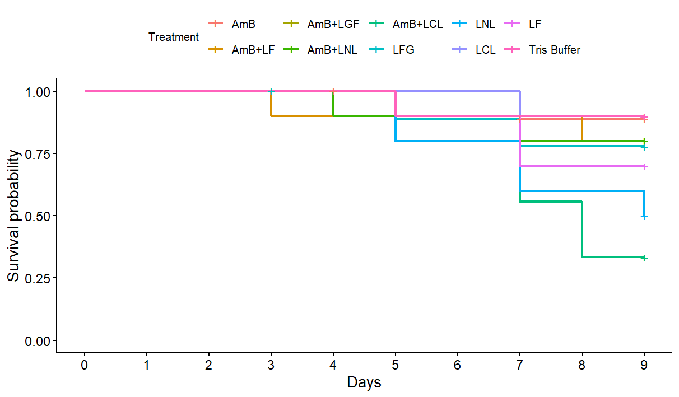

**Efficacy assay**

The survival rates for all treatment groups were quite comparable. While the first deaths occurred around Days 3-5, the majority of deaths occurred past Day 7 (**Fig 1**). There was no significant difference in survival between the combination therapies of AmB+peptide, χ2 (9, n = 10) = 15.5, p = 0.08. Thus, the null hypothesis that the combination therapies would not prove more effective than the mono-therapies, was not rejected. However, it is important to note that not even the mono-therapies performed no better than the negative control (Tris Buffer). Rather than a failure of antifungal efficacy, such results instead indicate an inadequate concentration of *C. albicans* SC5314 inoculum.

**Pathogenicity assay 1**

A *C. albicans* SC5314 inoculation dose of 106 CFU/larva was found have significantly reduced survivability compared to the 105CFU/larva dose, χ2 (1, n = 10) = 8.3, p = 0.004. Therefore, the null hypothesis, that a dose greater than 105 CFU/larva would not be required

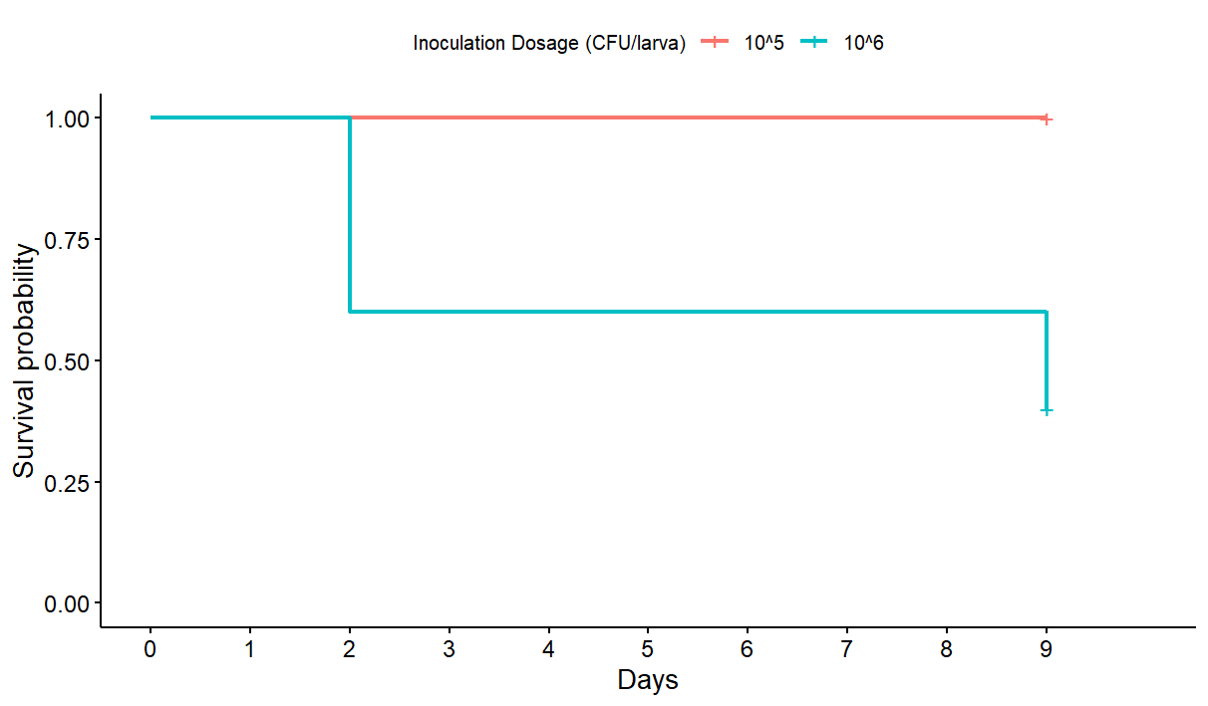

**FIG 2** Survival plot of the pathogenicity assay comparing two different inoculation doses. *G. mellonalla* larvae were infected with either 105 CFU/larva or 106 CFU/larva of *C. albicans* SC5314 (n = 10). Treatment groups were monitored for survival over 10 days.

to induce infection, was rejected. In fact, whereas the 105 CFU/larva treatment displayed no deaths over the monitoring period, the 106 CFU/larva treatment displayed decreased survivability as early as Day 2 (**Fig 2**).

**Pathogenicity assay 2**

All treatment groups displayed decreased survivability compared to the negative control (p = 0.0083), with the exception of the 105CFU/larva dose StockA (p = 0.3173). Additionally, the 106CFU/larva dose of StockA and both 105 and 106CFU/larva dosages of StockB displayed greater pathogenicity than the 105CFU/larva dose of StockA (p = 0.495, p = 0.495 and p = 0.461, respectively). This rejects the null hypothesis that there would be no difference in pathogenicity between the two *C. albicans* SC5314 stocks. While the survival probability of Stock A at 105CFU/larva remained at 0.75 from Day 2 onwards, the probability steadily declined for the other three stock/dosage treatments (**Fig 3**). However, there was no significant difference in the pathogenicity between these latter three treatments.

Data from *Pathogenicity assay 1* (now referred to as Trial 1)was compared against StockB from *Pathogenicity assay 2* to assess the reproducibility of this survival data from the same *C. albicans* SC5314 glycerol stock. It was also compared against the data from StockA of *Pathogenicity assay 2* to assess whether the expected differences in survival data between glycerol stocks is also reproducible. The pathogenicity of 105 CFU/larva groups for Trial1 and StockA did not differ, nor did the data for the 106 CFU/larva groups (p = 0.18428 and p = 0.08967, respectively) (**Fig 4a**). However, pathogenicity for both the 105 CFU/larva and 106 CFU/larva groups did differ between Trial1 and StockB (p = 0.00012, p = 0.02994) (**Fig 4b**). These results were unexpected, considering *C. albicans* SC5314 cultures for Trial1 and StockB were prepared from the same glycerol stock, whereas StockA was prepared from a separate glycerol stock.

**FIG 3** Survival plot of the pathogenicity assay comparing two different glycerol stocks of *C. albicans* SC5314. *G. mellonalla* larvae were infected with either 105 CFU/larva or 106 CFU/larva of *C. albicans* SC5314 cultures prepared from one of two glycerol stocks, StockA or StockB (n = 5). PBS was used as a negative control (n = 5). Treatment groups were monitored for survival over 10 days.

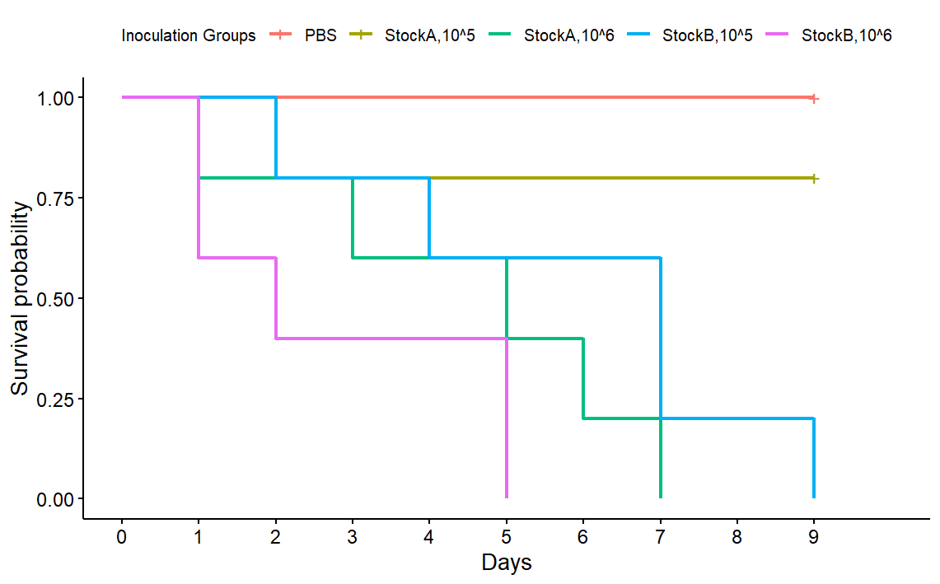

**Discussion**

The current study set out to determine the antifungal and AmB-synergy properties of the proteins and peptides LF, LFG, LCL and LNL. It was hypothesised that the combination

therapy of AmB and the truncated peptides (LCL and LNL) would have increased antifungal and synergistic activity compared to the respective monotherapies and the parent proteins, LF and LFG. However, due to the inoculum’s failure to kill any larvae, including those of the negative control group, the antifungal effect of the treatments could not be determined. As a result, the state of this first hypothesis remains inconclusive.

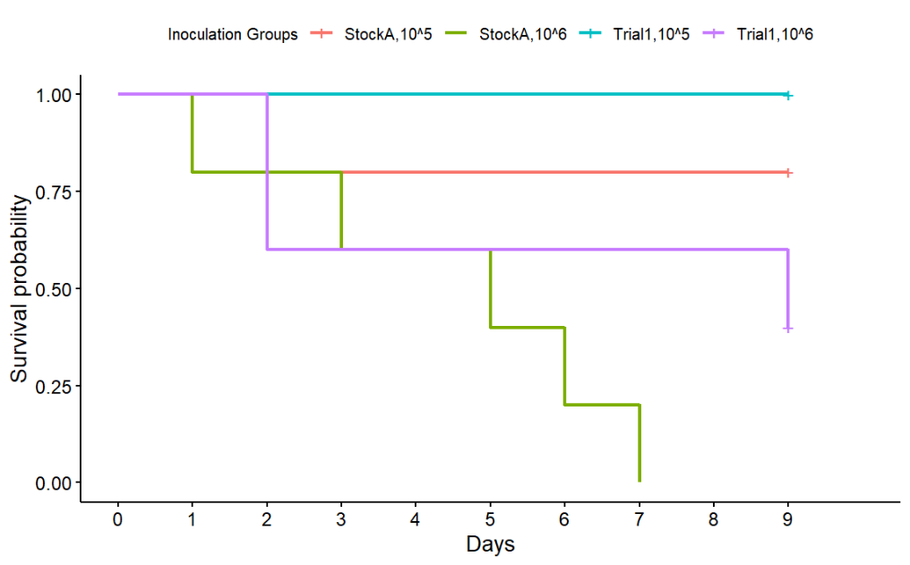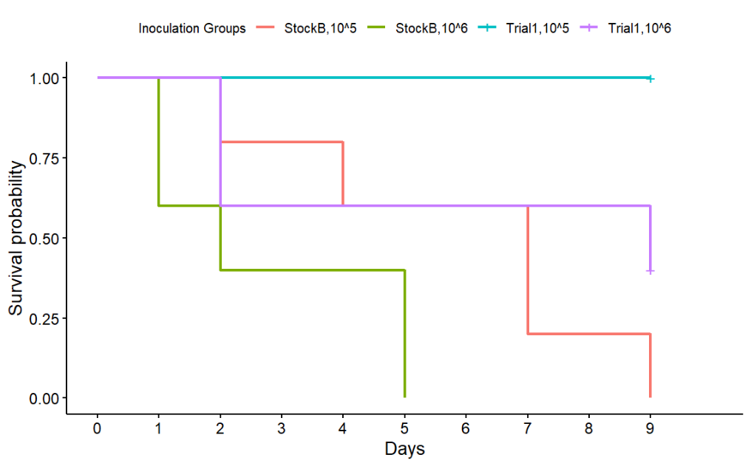

**FIG 4** Survival plots comparing the results of *Pathogeneticty assay 1* (Trial1) with the results of *Pathogenicity assay 2*, separated by glycerol stock. Comparisons for both 105 CFU/larva and 106 CFU/larva doses of *C. albicans* SC5314 are displayed. Plot **a)** compares Trial1 (n = 10) against StockA (n = 5), and **b)** compares Trial1 (n = 10) against StockB (n = 5).

**a)**

**b)**

Following the failure of the 105 CFU/larva dose, it was hypothesised that a greater dose of *C. albicans* SC5314 would be required to induce death. The first pathogenicity assay, which trialled doses of both 105 CFU/larva and 106 CFU/larva, supported this hypothesis. It once again displayed that a dose of 105 CFU/larva was inadequate, whereas a dose of 106 CFU/larva was sufficient to induce death in as early as 2 days.

While such findings made sense in the context of this study, they contradicted past pathogenicity assays conducted by other members of the Cain Group. These past assays found the 105 CFU/larva dose of *C. albicans* SC5314 to be adequate for a such a survival assay. It was noted that these past assays used a different glycerol stock of *C. albicans* SC5314 than that used in the current study. To further investigate the discrepancy between these two glycerol stocks, another pathogenicity assay comparing doses of 105 CFU/larva and 106 CFU/larva for both the past glycerol stock, StockA, and the current study’s stock, StockB, was performed. It was hypothesised that StockA would display increased pathogenicity compared to StockB. However, the survival assays found StockB to have greater pathogenicity than StockA at the 105CFU/larva dose. This was unexpected for two reasons. First, that based on the discrepancy in survival data between this study’s efficacy assay and the past pathogenicity assays, it was expected that StockA would have greater pathogenicity. Secondly, whereas the 105 CFU/larva dose for StockA was found to be pathogenic in the past, the current pathogenicity assay found it to be statistically indistinguishable from the negative control. This called in to doubt the reproducibility of survival data from such pathogenicity assays.

To further investigate this notion, the survival data from *Pathogenicity assay 1* was compared against the results from StockA and StockB from *Pathogenicity assay 2*. As Trial1 also used cultures recovered from StockB it was hypothesised that the Trial1 results would mirror the results of the second pathogenicity assay. More explicitly, that Trial1 survival data would differ to that of StockA but show a high degree of similarity to that of StockB. This investigation found more unexpected results, with a significant decrease in Trial1’s 106 CFU/larva dose compared to that of StockB. Moreover, there was no significant difference in results for either 105 or 106CFU/larva doses between Trial1 and StockA. Such discrepancies served to create more doubt around the reproducibility of this survival data.

The mechanisms behind the noted discrepancies are unclear. However, one uncontrolled variable potentially influencing the data is the mass of *G. mellonella* larvae used in the survival assays. The majority of larvae used were of a healthy and mature weight, between 200-250mg. However, depending on the volume of larvae available on the day of harvesting, some 180-200mg larvae were also randomly mixed throughout the sample pool. The weights of larvae used in each treatment were initially measured but not recorded. As such, the effect of weight variation within treatment groups was not known. The variations in survival data between *Pathogenicity assay 1* and StockB from *Pathogenicity assay 2* could be the result of this unquantified weight effect. This could also be responsible for the discrepancy between StockA and StockB from *Pathogenicity assay 2*, as well as the discrepancy between StockA and the Cain Group’s previous pathogenicity assays. In future experiments, recording the masses of larvae for each treatment group would help quantify this currently-unknown effect.

Another potential influence on discrepancies between survival assays is the sample size of treatment groups. *Efficacy assay* and *Pathogenicity assay 1* each used sample sizes of 10 larvae. However, due to low availability of larvae at the time of harvest, *Pathogenicity assay 2* only used 5 larvae per treatment group. Such a great difference in sample size likely contributed to the discrepancies in data between *Pathogenicity assay 1* and StockB from *Pathogenicity assay 2*. Moreover, even the sample size of 10 larvae per treatment group is likely too small for reliable and reproducible statistical analysis. For example, a similar survival assay conducted by Fernandes and colleagues used 30 larvae per treatment group, collated from 3 replicates of 10-larvae treatment groups3. While the efficacy project is currently intended to undergo such replicate measurements before final data analysis, performing similar replicates for the pathogenicity assays may aid to reduce the discrepancies in survival data.

Another potential cause of the noted discrepancies, raised by Cabrera, was improper labelling of the glycerol stocks. StockA and StockB were supplied from separate institutions. As such, there is a possibility of a mistake in strain labelling from one or both institutions. Such mistakes would also explain the odd results from these pathogenicity assays. To investigate this notion, genetic sequencing of colonies would definitively identify each stock to the strain level. However, due to the cost and impracticality of such an endeavour, this should only be considered after more simple approaches (such as controlling for larva mass, increasing replicates, etc.) have been attempted.

**Conclusion**

The study aimed to investigate the antifungal and AmB-synergy properties of the proteins and peptides LF, LFG, LCL and LNL against the model pathogenic fungi, *C. albicans* SC5314. However, due to procedural errors, this focus of this study shifted to investigating the pathogenicity of different doses and glycerol stocks of *C. albicans* SC5314. A dose of 106 CFU/larva was determined to be an adequate dose for conducting a pathogenicity assay. Moreover, StockB was found to be more pathogenic than StockA. However, these results contradicted the findings from previous investigations within the Cain Group. Further investigations involving controlling for larva weight and increasing sample size could help in reducing such discrepancies and producing more reliable and reproducible data.

**Acknowledgements**

I would like to thank the Cain Group and the *Macquarie Galleria Research Facility* for taking me on as a placement student and allowing me to participate in their projects. I would especially like to thank my placement supervisors, Dr Amy Cain and Research Officer Andrea Cabrera, for their guidance and mentorship throughout the course of this project.

**Data Availability**

Raw notes from my lab book are available in the PDF file, *Placement2_LabBook_IsaakSalami_46625143* that accompanies this report. All datasets and R scripts for statistical analysis are available at: <https://github.com/isaak11salami/FOSE7901_Placement2>

**References**

1. Nnadi, N. E. & Carter, D. A. Climate change and the emergence of fungal pathogens. *PLOS Pathog.* **17**, e1009503 (2021).

2. Nicola, A. M. *et al.* Antifungal drugs: New insights in research & development. *Pharmacol. Ther.* **195**, 21–38 (2019).

3. Fernandes, K. E., Weeks, K. & Carter, D. A. Lactoferrin Is Broadly Active against Yeasts and Highly Synergistic with Amphotericin B. *Antimicrob. Agents Chemother.* **64**, 10.1128/aac.02284-19 (2020).

4. Fernandes, K. E., Payne, R. J. & Carter, D. A. Lactoferrin-Derived Peptide Lactofungin Is Potently Synergistic with Amphotericin B. *Antimicrob. Agents Chemother.* **64**, 10.1128/aac.00842-20 (2020).

5. Dinh, H., Semenec, L., Kumar, S. S., Short, F. L. & Cain, A. K. Microbiology’s next top model: Galleria in the molecular age. *Pathog. Dis.* **79**, ftab006 (2021).

6. R, A. N. & Rafiq, N. B. Candidiasis. in *StatPearls* (StatPearls Publishing, Treasure Island (FL), 2025).

7. Posit team. RStudio: Integrated Development Environment for R. Posit Software, PBC (2025).

8. Therneau, T. M., until 2009), T. L. (original S.->R port and R. maintainer, Elizabeth, A. & Cynthia, C. survival: Survival Analysis. (2024).

9. Kassambara, A., Kosinski, M., Biecek, P. & Fabian, S. survminer: Drawing Survival Curves using ‘ggplot2’. (2024).

10. Wickham, H. *et al.* ggplot2: Create Elegant Data Visualisations Using the Grammar of Graphics. (2025).